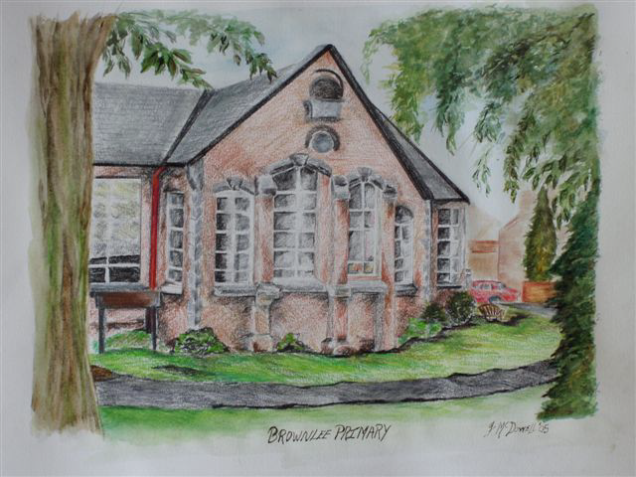
BROWNLEE PRIMARY SCHOOL

Period Dignity Policy
2023

Brownlee Primary School
Period Dignity Policy

Aims of the Policy:
This policy will address the importance of accessibility and availability of essential care in Brownlee Primary School.
We aim to ensure that:
- Pupils are provided with facts about menstruation;
- Children are given a comprehensive understanding of menstrual wellness, and how this impacts physical and emotional wellbeing
- We educate children about menstrual hygiene – essential facts and how to deal with related situations
- Negative attitudes, myths and stereotypes are challenged

This policy has been developed in line with the following guidance:
- The Equality Act (Sexual Orientation) Regulations (Northern Ireland) 2006
(www.legislation.gov.uk)
- United Nations Convention on the Rights of the Child (UNCRC) (www.unicef.org.uk)

- Every School a Good School, Together Towards Improvement and Community Relations, Equality and Diversity in Education Policy (www.deni.gov.uk)

- Menstrual Well-being in the RSE Curriculum https://ccea.org.uk/learningresources/relationships-and-sexuality-education-rse/menstrual-wellbeing
The policy will be reviewed in September 2025 by the Period Dignity key contact (Mrs McFarland) and the Principal (Mr Montgomery).

Our Ethos:
The members of staff in Brownlee Primary School are highly committed to the care and well-being of each child, have a deep sense of pride in our school and community, and work together to contribute to the holistic development of all children entrusted to our care. We seek to provide a safe environment to break the stigma surrounding periods and promoting respect, understanding and open discussions about what girls may experience when menstruating. Period Dignity is an integral part of the development of our pupils in line with the following Pastoral and Safeguarding policies:
- Child Protection policy
- Intimate Care policy
- Safeguarding policy
- Pastoral Care policy
- RSE policy
- SEN policy
- Positive Behaviour policy
- Anti-Bullying policy
- First Aid policy
- Relevant Education Authority guidance and risk assessments for accidents and sickness

Roles and responsibilities:
The Period dignity programme is a whole school initiative, involving pupils, parents, staff and Governors. The policy will be made available to parents on our school website and paper copies are also available on request from reception. Parents are given information about period dignity and the sanitary items available for pupils in school, when appropriate, through Class Dojo. The policy will be uploaded onto the school’s website and the organisation, Love for Life will visit the school each year to speak to the children about puberty. This visit includes a separate session with the girls in P7 and deals specifically with menstruation. Love for Life also carries out a parent workshop and this information session provides parents with a forum to ask questions and learn about how the subject of puberty and body changes will be taught in school.
The Board of Governors is responsible for overseeing the implementation of Period Dignity as it reviews all the relevant policies and liaises with key members of staff. Members of the Board of Governors are also welcome to attend any parent workshops dealing with this subject.
Mrs McFarland (Designated teacher) is the Period Dignity Key Contact. She works closely with Mrs Duffy (DDT) and all staff members of staff to ensure a whole school approach is implemented.

Whole-school approach to period dignity:
RSE is taught throughout the school in every key stage as part of PDMU using cross curricular themes, practical activities and group/partner work.
Period Dignity lessons are taught in gender groups in Primary 7 and Love For Life assists with the delivery of these.
Our aim is to ensure age-appropriate, sensitive and relevant information on puberty is provided for both boys and girls, regardless of ethnicity, culture and religion.
Lessons will be differentiated to accommodate SEN pupils, where appropriate.
These activities will address the stigma and myths around periods and create an atmosphere of positivity and open communication in order to increase pupils’ knowledge, confidence and well-being.
As part of these activities, children may discuss, ask questions and make decisions to equip them for real situations.
By providing appropriate period dignity education, we will encourage pupils to make use of the free period products provided in school, rather than wearing poor quality or unhygienic products.
Teaching staff evaluate their lessons and pupils will have an opportunity to give feedback on their learning throughout any sessions dealing with Period Dignity or puberty. Girls will be encouraged to discuss the availability of period products in school, if necessary. Any lessons on this topic will be monitored and reviewed by Mrs McFarland as part of the school’s half-term and weekly planning.
Senior girls will be informed of the period dignity scheme and the items available to them in school in September. They are advised of the teachers they should approach if they have any issues (Mrs McFarland, Mrs Duffy & Mrs McManus).
The products are ordered after consultation with staff and pupils to ensure suitable items are purchased.
A range of sanitary towels will be kept by Mrs Duffy and is available for girls at all times.
The products are stored and replenished by these members of staff when necessary, checking expiry dates on a termly basis.
The girls’ toilets will also have designated cubicles for senior pupils and these will contain waste containers, especially for sanitary products.

Links across the curriculum and to the wider life of the school
The understanding and knowledge of period dignity and menstrual well-being will be taught mainly through our PDMU and RSE curriculum, with links, where appropriate to ICT, WAU and Literacy.

The emotional health and well-being of pupils is a key priority in our SDP, and therefore a whole school focus.
The period dignity programme compliments work being carried out in Shared Education as we focus on mutual respect and the rights of the child. RSE, PDMU and EHWB lessons are centred around growth, understanding and developing knowledge and understanding of ourselves and others.

Managing Issues
Staff will be vigilant for any children who are distressed or experiencing discomfort due to menstruation. Children will be treated with care and sensitivity. Pupils will be given support and period products will always be available.
Swimming takes place for pupils in years 4 to 7 throughout the school year. Girls who are menstruating at the time of their swimming sessions will be treated in a sensitive manner and supported as required.
Staff will work alongside parents, to ensure that absences are not caused by children unable to manage periods or lacking confidence with their own intimate care. Parents will be informed of any issues that arise.

This policy will be reviewed in 2025.

