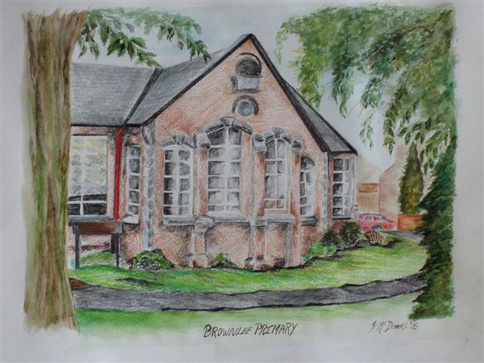
BROWNLEE PRIMARY SCHOOL
Positive Behaviour Policy

2023

This policy was adopted by the Board of Governors in October 2023
It will be reviewed by the Board of Governors in 2025 or at such times as new guidance becomes available or relevant legislation is passed.
Brownlee Primary School
Positive Behaviour Policy

Aims of the School in Relation to Discipline
In interpreting the obligations placed upon it by the NI Order, the Board of
Governors, in consultation with and guided by the Principal, have set out the
following aims:

- to enable all the pupils to acquire habits, skills and knowledge, interests and attitudes, which will assist them to live full and useful lives.
- to set and inspire standards of behaviour, effort and excellence by which pupils can measure their own conduct and achievement.
- to create an environment which is best suited to social development.

These overall aims are translated into more specific aims for the daily routine of
the school:
- to provide for the intellectual, moral, physical, social and spiritual development of all pupils.
- to provide a safe, caring and stimulating learning environment.
- to enable all pupils to achieve their full potential through the provision of balanced and appropriate areas of study.
- to foster self discipline and self respect and an appreciation of moral values.
- to promote high standards of behaviour.
- to promote respect for others, with an understanding of cultural, religious, social and other differences.
- to arouse children’s curiosity and to foster a desire to learn about the world in which they live.
- to provide pastoral care giving support and guidance at all times.
- to encourage an appreciation of, and practical experience in arts, music, The World Around Us and literature.
- to help, pupils prepare for their adult lives at home, at work and at leisure by developing self-confidence, motivation, initiative, self-regulation and positive attitudes so as to live as independent adults.

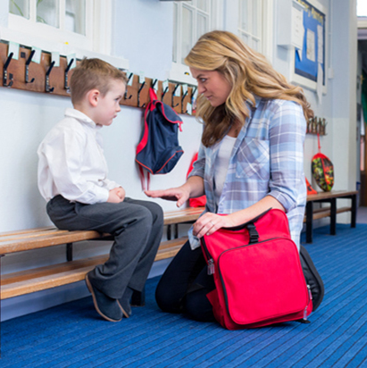
The Need for Positive Behaviour
Positive Behaviour is the system and ethos which aims to cultivate in pupils an acceptance and recognition of responsibility for their own decisions, their actions and their consequences. Good discipline practices create the conditions for effective learning and help to develop in children responsible attitudes and values for life.

It is the view of Brownlee Primary School that effective learning can only take place in an atmosphere where standards of good behavior and respect are set as prerequisites.

Good behaviour is that conduct which assists the school to fulfill its function; namely the full development of the potential of all its pupils.

Poor or challenging behaviour is conduct which prevents this, either when an individual hinders his/her own development by behaving badly or when unacceptable conduct disrupts the development process for other members of the school community. It therefore follows that good behaviour is that which:

(I) conforms to the reasonable expectations and requirements of the
school.

(ii) is based upon mutual respect for the needs and aspirations of all in the
school and upon care for its environment.

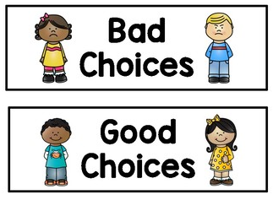
Aims of Positive Behaviour
Positive behavior is both an attitude as well as a system of rules for good behaviour which aims to create conditions for an orderly community. Our school’s Positive Behaviour aims are:

(i) to have a disciplined, caring and happy environment conducive to learning;

(ii) to encourage the development of self-discipline, self-esteem,
independence and respect for the feelings and opinions of others;

(iii) to encourage a degree of understanding of religious and moral
Standards, respect for difference and a regard for the law of the land.

A system of Positive Behaviour should have at its centre a concern for the safety and well-being of the pupils. The application of sanctions should not be seen as merely ‘punishment’ but as the training of children to behave in a socially acceptable fashion while in the care of teachers and others in our school. It may well be that ‘punishment’ - in the form of an appropriate sanction - is part of this training, but generally discipline should aim to be positive.

Positive Steps towards Good Discipline
(i) Pride in our school as a worthwhile institution will be encouraged both
explicitly and implicitly. Its history and the many family connections
should be emphasised. The wearing of school uniform will be strongly
encouraged as it gives a common sense of identity and is a policy agreed by
the school’s Board of Governors.

(ii) A positive, pleasant classroom environment will be created where
children have meaningful work related to their ability and where
enthusiasm and industry dominate.

(iii) Pride in our school environment will be created by well-maintained grounds,
clean buildings and attractive wall displays. Children will be encouraged to
respect these and helped both actively and passively to maintain these.

(iv) Children will be encouraged to fulfill their potential both in the classroom
and in extra-curricular activities.

(v) Respect for law and for religious and moral standards will be stressed at
suitable opportunities.

(vi) Children will have a clear understanding of class and school rules and why
they are important, with emphasis on reward, praise, good attitudes and
setting a good example.

(vii) Children will be expected to exhibit good manners at all times. Adults
should be addressed by title as appropriate i.e. “Yes Mrs. McFarland” or “Yes Mr. Montgomery.” The use of “Please”, “Thank you” and “Excuse me” will always be expected. Children will be able to model themselves on the example of staff in regard to courtesy and respect both to other staff and children.

(viii) At all times active supervision will be expected from staff to ensure the
school’s Discipline Policy is being adhered to.

(ix) Praise and the expectation of high standards of behaviour are ultimately
probably more effective than sanctions.

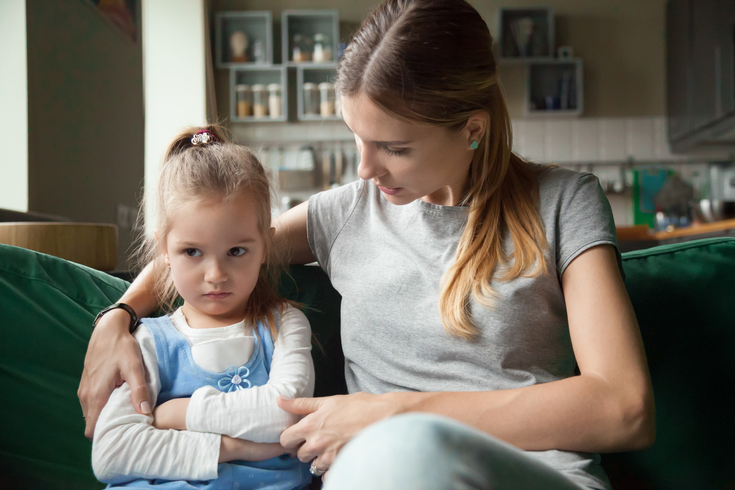
Parents and Positive Behaviour
Standards of behaviour are well established in children before they come to school. The accepted standards of behaviour will vary from home to home and family to family, but conflict arises when the expectations of school are different from those of home. Often in a smaller community such as the home, individual needs can largely be accommodated without undue disturbance, but a school is a much larger community where the interests of each individual have to be addressed in relation to the children as a whole.

It is quite clear that a pupil’s acceptance of any system of rules for behaviour is determined by the attitudes of home and local society. Therefore, parental acceptance of the school’s expectations and active co-operation with the staff is absolutely essential if an acceptable standard of discipline is to be achieved. Although parents are not in school with the children, their influence is still greater than that of a class teacher.

Parents have a duty to ensure that their children do not cause injury or damage to others or to any property and they, therefore, have an obligation to promote the general policy and rules of discipline as laid down by the school.

The co-operation of parents is sought in relation to maintaining high standards of pupil attendance, punctuality, personal appearance, the wearing of school uniform, caring for learning materials, particularly those which belong to the school or which may be sent home and the supervision of homework.

It is also important for parents to be aware that their child may behave differently among their peers at school than they do at home. Therefore, parents need to be willing to accept that their child may have behaved in school in a way which may seem out of character when compared to the same child’s behaviour at home.


Rewards - The Positive Side of Discipline
It is part of the school policy to emphasise positive approaches to maintain
the improved discipline.

Praise
Praise can be given in many ways and, without any attempt to put this into a value order, might include the following:

- a quiet word or encouraging smile;
- a written comment on pupil’s work, or in a more detailed way picking out
specific points or ideas that gave pleasure;
- a visit to a colleague in the same year group or to a more senior member
of staff and/or the Principal for commendation, e.g. a written comment or
sticker;
- a public word of praise in front of a group, a class, a year or the whole school;
- public acknowledgement by presentation at an assembly or by giving some special responsibility;
- some system of merit awards, with or without public acknowledgement of that reward e.g. “Pupil of the Week” or awarding a star to the class’ star chart.
- school awards for good citizenship or integration;
- additional awards which reflect endeavour;
- use of school reports to comment favourably, not only on good work and
academic achievement, but on behaviour, on involvement and on general
attitudes;
- a communication to parents informing them specifically of some action or
achievement deserving praise.

Classroom Discipline
Good teaching and positive teacher/pupil relationships are major contributors to good classroom discipline. Good discipline enables effective learning to take place and in order to achieve this goal the following strategies should be implemented;

- the encouragement of genuine involvement of all pupils in classroom;
- actively recognising children’s different abilities and matching tasks to those abilities so that pupils regularly achieve success;
- the recognition and encouragement of children’s individuality and the
importance of self-esteem;
- attempting to make lessons enjoyable and challenging with an approach which is sufficiently flexible to encourage children’s contributions;
- the use of positive rather than negative language to communicate expectations and feedback to pupils;
- giving regular praise and encouragement to pupils, particularly to
disruptive pupils as soon as acceptable behaviour is observed;
- the establishment of a small number of classroom rules which should be discussed, if appropriate, with pupils to encourage ownership.
- A consistent approach to Positive Behaviour by all school staff with high expectations at all times.

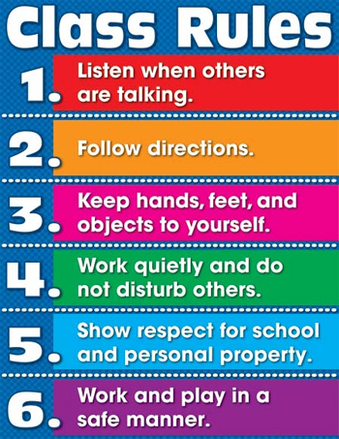
School Rules
In order that pupils should behave responsibly towards themselves, towards others and towards their environment, there are certain areas of school life where it is necessary to indicate expected standards of behaviour.

Guidelines for Staff when Rules are Broken.
These guidelines are designed to avoid negative and emotionally charged confrontations which are detrimental to both teacher and pupil. They are aimed at creating a positive learning environment where:

- people are courteous;
- communication is good;
- rules are reasonable, beneficial to the individual and the group;
- the approach to discipline teaches self-responsibility and self-regulation.

It is important to note that children who have Personal Education Plans for social / emotional issues may require additional adult support and time out from the rest of the class with a classroom assistant. This is to both provide a de-escalation of a situation and also an opportunity for the remainder of the class to learn without interruption.

The stages below are a guide and may be used at the discretion of the teacher / senior management depending on the context of each individual case.

Stage I
Discussion
Teacher will talk with pupil to try to reach an understanding so behaviour will improve.

Removal of Privileges
This will be left to the discretion of the teacher.

Detention –
Keeping a child in during break or lunch time or exclusion from class activities. This may mean separating the child from their peers within the room or activity. Children however should never be placed outside a classroom unsupervised. This may not be able to be used as a sanction during COVID-19 restrictions in order to protect the integrity of class bubbles.

Meeting with the Principal or a Senior Member of Staff
The child may have to be spoken to by the Principal or a senior member of staff so they appreciates the seriousness of the behaviour which has taken place. In such instances the child’s parents will be informed that such a meeting has taken place.

Meeting with Parents and the Principal or Senior Member of Staff
Following this and at the Principal’s discretion, parents may be asked to discuss the problem on an informal basis. During the COVID-19 restrictions, discussions with parents may be carried out remotely by telephone, Zoom or through a socially distanced meeting.

Stage 2
Continuing Behaviour Issues

Parent / Teacher / Pupil Interview
This is a more formal meeting and a record of discussions and decisions reached will be kept on file. During COVID-19 discussions with parents may be carried out remotely by telephone, Zoom or through a socially distanced meeting.

Exclusion from Classroom / Activity
The pupil may be moved to an appropriate space with supervision. Sending child somewhere away from the situation (i.e. the upstairs office) until the child is willing to accept the need to improve his/her behaviour.

Daily Report
Maintenance of a daily report to be signed by the parents and the teacher. This can be done through Class Dojo or another online method and should not record every minor infringement of the rules but incidents which provide evidence of perhaps an underlying condition. Examples of good behaviour should also be recorded in this daily report book.

Stage 3
Intervention
Seeking specialist assistance. For example, RISE NI, Psychology Department or Behavioural Support at the Education Authority.

Stage 4
In exceptional circumstances it may be necessary to reduce a child’s day at school. This is always looked at as a short term arrangement and time in school will be increased as the child’s behaviour improves.

Stage 5
Suspension
All decision with regard to the suspension of a pupil will be undertaken by the Principal and the school’s Board of Governors. All procedures will be in line with the agreed policy from the Education Authority and their advice and support will also be sought at this stage.

Parents may also be asked to collect their child early from school if the behaviour displayed from a pupil is extremely disruptive or deemed to be impacting on the safety, well-being and safety of the other children in the class. This will only be used if the child’s welfare or the welfare of others will be compromised if the child remains on the school premises and the Principal feels that a formal suspension is not appropriate.

The Department of Education’s ‘Reopening Schools Guidance’ – August 2020 states:

“The school’s pupil behaviour policy should be reviewed to ensure that it covers COVID-19 related incidents and should make provision for the school to be able to sanction, up to and including exclusion, pupils who wilfully refuse to adhere to arrangements of social distancing and deliberately cough or spit at pupils or staff, putting them at risk.”

This sanction would hopefully only be used in an extreme case and for a short period. The decision on such action will be taken by the Principal or in his absence, a senior member of staff.

All the above stages are descriptive rather than prescriptive. The procedure undertaken when a rule is broken will depend on the context of the case.

The above procedures are intended to be a flexible arrangement where guidelines only are offered to encourage and modify certain types of behaviour.
Teachers can only be responsible for the safety of children on the school premises for the duration of the school day and for the duration of after school activities and educational visits.

Safety
Children should not be on school grounds prior to 8.40am. If children do arrive before this time they will be placed in the Early Bird Club and the child’s parents charged. Similarly, classes are dismissed in the afternoon at 1.45pm, 2.00pm, 3.00pm and 4:00pm during after school activities. Children must be collected promptly at these times and if they are not collected the child will be placed in the After School Club and an appropriate fee charged. During the COVID-19 pandemic, the prompt arrival and collection of children from school will be extremely important and parents will be reminded of this.

Any change in the normal routine of travelling home from school by a child
should be reported by parents to either the class teacher or Principal.

Children must not leave the classroom or school premises for any purpose
during the school day without permission from the Principal or class teacher.

- Children must wear the recognised school uniform at all times, unless given permission to do otherwise.

- Children must be properly dressed for all PE activities, i.e. tracksuit / shorts, T-shirt/polo shirt, plimsolls and trainers for outside games.

- All jewellery, including earrings, should be removed prior to the start of a PE lesson. The child should be able to remove these or alternatively earrings should not be worn on PE days. Parents are asked not to have their child’s ears pierced during the school term but to wait until the summer holidays when the piercing has had a chance to heal.

- There should be no boisterous behaviour within school grounds at any time.

- Valuables, including electronic devices and large amounts of money owned by the children must be left at home as teachers cannot accept responsibility for loss or damage.

- All money payments should be made through the Brownlee App so no physical money is brought into school.

- Children who bring drinks should use non-breakable containers.

- No item of equipment must be brought outside, or used without a teacher’s permission.

Courtesy
- At all times children must be courteous to each other, their teachers and all other adults at school.

- Children should remain quiet and respectful during school assemblies.

- Children must treat their own, other children’s and school property with respect.

- Reasons for absences from school should be reported to the class teacher in writing on ClassDojo following the child’s return to school.

- Parents wishing to consult teachers will be given an appointment on request.

Use of the School Building
- Children must enter and leave the school building by the designated entrances unless otherwise directed.

- Children must walk in an orderly manner inside the school.

- Children must keep to the left-hand side of all corridors when moving around the school.

- Children must line up outside their classroom in an orderly fashion until
Instructed by a member of staff to go in.

All instructions to children from the Principal, teachers or non-teaching staff are expected to be obeyed immediately and without question.

Sanctions in More Detail
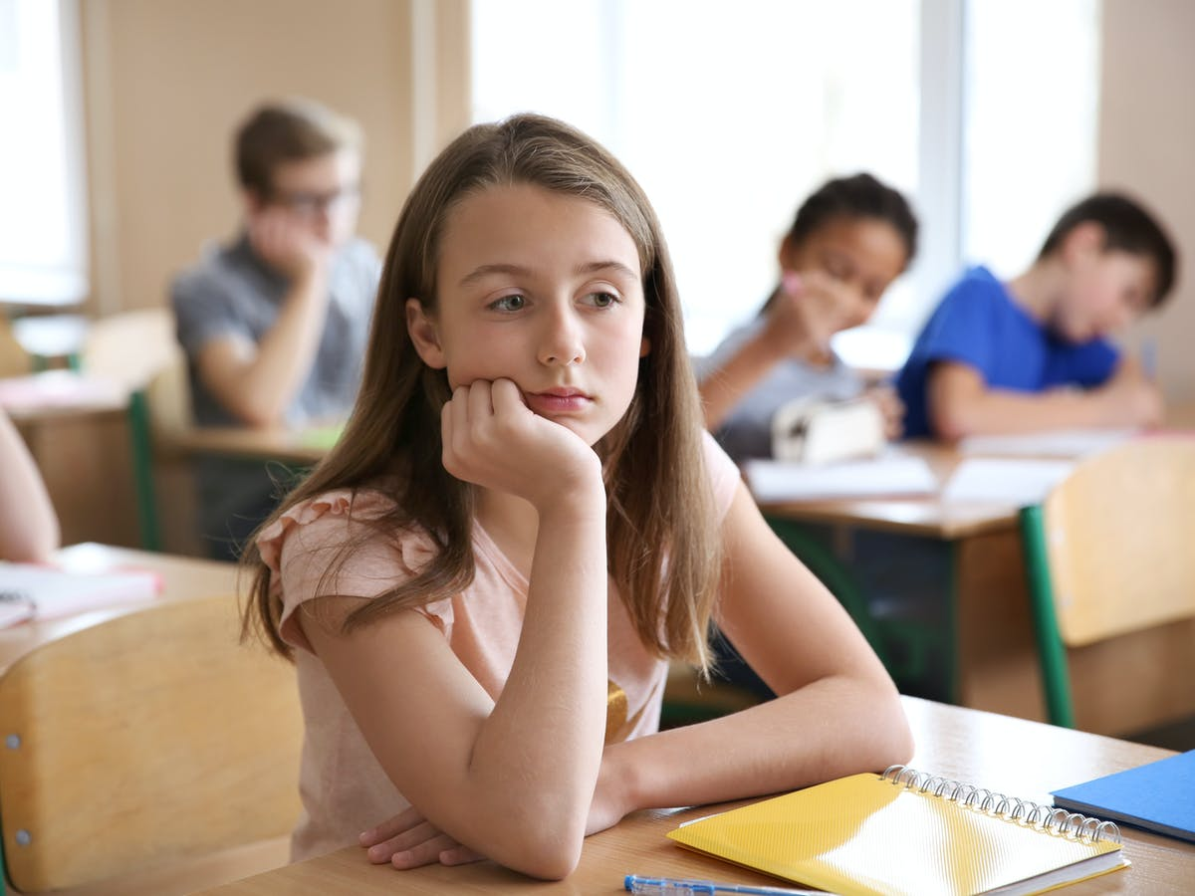
Even with good classroom practice it will be necessary to have sanctions.

These are necessary for two main reasons:
- to make the particular child and others aware of the school’s / teacher’s disapproval of unacceptable behaviour;

- to protect the authority of teachers, should that be compromised by a pupil’s poor behaviour.

Sanctions should:
  - be constructive;
  - be applied with sensitivity, flexibility and discrimination;
  - where possible, be related to the misdemeanour;
  - be specific to the culprit and not applied to a whole group.

Sanctions will include:
- a look of disapproval;
- immediate verbal checking of misbehaviour;
- a minor penalty, relevant to the offence, e.g. an apology, picking up litter; “Thinking Chair”, withdrawal from some activities;
- repeated, or extra work, where the presentation or content of work is clearly below the pupil’s potential;
- loss of freedom, e.g. break time or lunchtime subject to the proviso that the child is given sufficient time for eating his/her meal, toileting, and is adequately supervised by staff. Extra work will be set to engage the pupil.
- loss of privileges;
- referral to the Vice-Principal or to the Principal; – This should only happen when an issue has reached a point where it cannot be dealt with by the staff in the classroom.
- parental consultation - this should come at an early stage and has the advantage of being a sanction, of throwing more light on the problems behind the misbehaviour and of providing joint / consistent action between school and home;
- placing on daily report. This will be on a daily basis and requires a comment from all staff teaching the pupil and from parents. This may be done using Class Dojo or another online platform.

While there is not a value order placed on the above list of sanctions, certain procedures should be followed, e.g. if after several verbal warnings by the class teacher bad behaviour persists, a ClassDojo message or phone call to the parent may be required. The Principal will be kept fully informed of any such situation.

Teachers should consider themselves responsible at all times for the behaviour of pupils within sight or sound of them. Responsibility for the behaviour of all pupils in the school is one, which all teachers share. In all matters relating to the maintenance of discipline and the application of sanctions, it must be remembered that our aim is to develop self-discipline in our pupils as well as build and maintain their self-esteem. We must, therefore, inspire pupils to an autonomous and personal decision to have a high standard of behaviour rather than subject them to it.

It is also important to remember that the child starts afresh once the sanction has been carried out.

Scheme for Suspension and Expulsion of Pupils
Suspension as a severe sanction will be considered only when all reasonable attempts to integrate the pupil into the school have been made.

It shall be imposed by the Principal, after consultation with the Board of
Governors, the parents, the Education Authority and any other appropriate body.

It shall be applied:
- where all possible preventive strategies and sanctions have been tried;
- if all possible preventive strategies and sanctions fail to produce acceptable behaviour;
- Where there has been a gross act of unacceptable behaviour by the pupil.

The Department of Education’s ‘Reopening Schools Guidance’ – August 2020 states,

“The school’s pupil behaviour policy should be reviewed to ensure that it covers COVID-19 related incidents and should make provision for the school to be able to sanction, up to and including exclusion, pupils who wilfully refuse to adhere to arrangements of social distancing and deliberately cough or spit at pupils or staff, putting them at risk.”

Reasons for Expulsion
The expulsion of a pupil will happen only as a consequence of the pupil having committed a most serious breach of school discipline. The Principal will take the appropriate steps and follow guidance as laid down by the Education Authority.
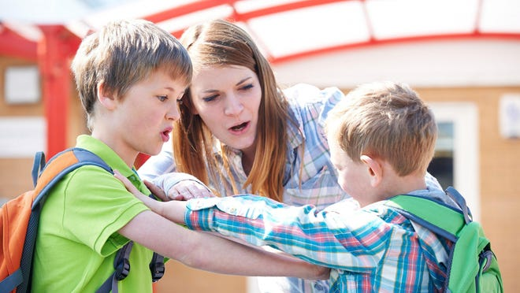
Safe Handling
All schools have a pastoral responsibility towards the pupils in their charge and should therefore take all reasonable steps to ensure that the welfare of pupils is safeguarded and that their safety is preserved. The Board of Governors and the Principal of Brownlee Primary School also have a duty to promote and secure good behaviour and discipline on the part of the pupils at the school.
It is not possible to be specific about the appropriateness of each physical contact, since an action that is appropriate with one child in one set of circumstances may be inappropriate in another, or with a different child. Staff should, therefore, use their professional judgement at all times. As a general rule, when physical contact is made with pupils this should be in response to their needs at the time, of limited duration and appropriate given their age, stage of development, gender, ethnicity and background. Appropriate physical contact in schools may occur most often with younger pupils, for example, physical comforting can give welcome reassurance to a distressed younger child.
In extreme cases, a staff member might have to physically restrain a pupil to prevent him or her from committing an offence, from causing injury to him or herself, to others or to property, or otherwise from behaving in a very undisciplined way. Staff are empowered to use reasonable restraint in these circumstances, either on school premises or anywhere else where the member of staff is in lawful charge of the pupil concerned. In such instances no more than the minimum necessary restraint should be used. Staff should act within the Department’s and the Education Authority’s (EA) guidelines on the use of reasonable force and should seek to avoid causing injury to the pupil.

Article 4 of the Education (Northern Ireland) Order 1998, which came into force on 21 August 1998, clarifies powers, which already exist under common law. This guidance is also contained in the 2017/04 circular ‘Safeguarding and Child Protection in Schools section 10.2.

This enables a member of staff of a grant-aided school to use, in relation to any pupil at the school, such force as is reasonable in the circumstances to prevent a pupil from;

- committing an offence;
- causing personal injury to, or damage to the property of, any person (including the pupil himself); or
- engaging in any behaviour prejudicial to the maintenance of good order discipline at the school or among any of its pupils, whether during a teaching session or otherwise.

The right of a member of staff to use such force as is reasonable to restrain or control a pupil applies;

- where the member of staff is on the premises of the school; or elsewhere at a time when he/she has lawful control or charge of the pupil concerned;
- to teachers at the school, and to any other member of staff who with the authority of the Principal has lawful control or charge of pupils.

The need to use safe handling to restrain or control a pupil is rare and it is emphasised that corporal punishment remains unlawful. This in no way authorises teachers or others to use any degree of physical contact which is deliberately intended to cause pain, injury or humiliation.

As far as possible, all safe handling measures will have to take place in accordance with the school’s COVID-19 procedures.

A formal written record must be kept of all incidents of reasonable force and / or physical restraint. This will be available from the Principal.

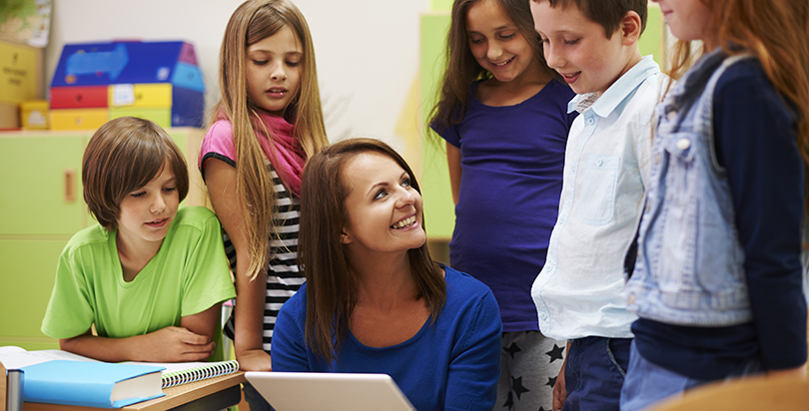
Staff and Discipline
The attitude of all staff is of great importance. It is they who, in the end, determine the environment in which good pupil/teacher relations can develop.

They are expected to set the right example to pupils in matters of dress, punctuality and commitment. Good behaviour in pupils is found where teachers enjoy good relationships with their pupils, have high expectations of their pupils’ work and provide a curriculum and teaching methods well matched to pupils’ needs.

A teacher’s influence depends on attitude, character, example, teaching
skills and the rapport established with pupils.

Above all, consistency of approach is the keynote - consistency by an
individual member of staff towards pupils and consistency across the staff
as a whole towards all pupils.

Consistent action by all the staff is required to make the policy effective. Any significant amendments to the school’s policy should be the basis of full and genuine consultation, leading to secure ownership and commitment.

Basic discipline practices throughout the school will be reviewed regularly, alternative ways of dealing with disruption will be considered and there will be access to literature and training from INSET providers.

